**An Application of the Derivative in Engineering (Optimal Design of an Aluminum Can)**

**Problem Statement**: The derivative plays a role in determining how containers can be designed. Suppose we wish to design a container to hold 16 ounces of soda (470 ml.) There are a couple of constraints that are placed on our design. The first is that the design should be cylindrical. The second is that the container should be capped at both ends.

**Solution**: The Figure shows the rudiments of the can design. It is easy to see that two variables r (radius of the can in cm) and h (height of the can in cm) are at play in this design.

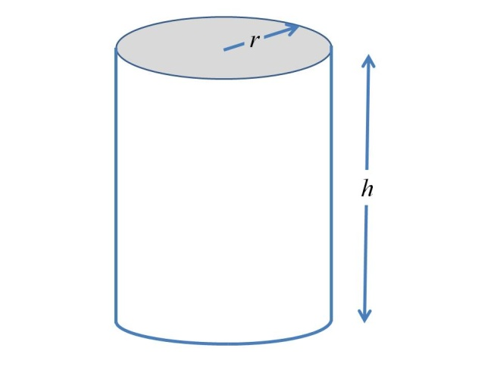

The design calls for the surface area of the can to be minimized. The surface area can be expressed in terms of *r* and *h* as:.

The formula for volume of a cylinder is  . The container must be designed to hold 470 ml of soda, so the design must satisfy the constraint equation 

This equation can be solved for *h*. Solving for *h*, we obtain  We proceed to substitute this expression for *h* into the equation for *Surface area*. We obtain the revised equation  We can simplify the equation to obtain an expression for surface area, *A*(*r*), that depends solely on the variable *r*, 

Next, we can find the derivative of A(r), .

We proceed to find the stationary points by setting the derivative to 0.



Now, we find the second derivative of A(r) to determine if the value *r* = 4.21 leads to a maximum or minimum of the surface area. 

Next, we substitute the value *r* = 4.21 into the expression of the second derivative. We conclude that the second derivative is positive at the point, that is  We thus conclude that the surface area *A*(*r*) achieves a minimum when the value for *r* is 4.21 cm.

We are not quite finished with the design. The next step is to determine the height of the container, *h*. We obtain the value for the height as follows:



Therefore, the minimum surface area is obtained for a cylindrical container with capped top and bottom, when the dimensions are and 